**Binary Tree**

A binary tree is a tree data structure in which each parent node can have at most two children. Each node of a binary tree consists of three items:

* data item
* address of left child
* address of right child

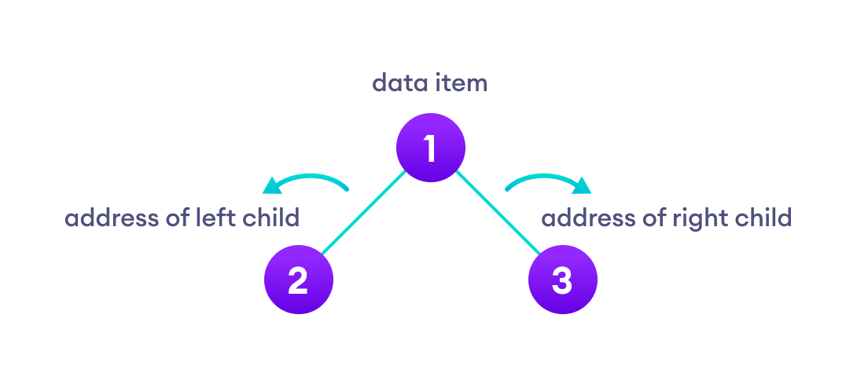

# Properties of Binary Tree

* At each level of i, the maximum number of nodes is 2i.
* The height of the tree is defined as the longest path from the root node to the leaf node. The tree which is shown above has a height equal to 3. Therefore, the maximum number of nodes at height 3 is equal to (1+2+4+8) = 15. In general, the maximum number of nodes possible at height h is (20 + 21 + 22+….2h) = 2h+1 -1.
* The minimum number of nodes possible at height h is equal to **h+1**.
* If the number of nodes is minimum, then the height of the tree would be maximum. Conversely, if the number of nodes is maximum, then the height of the tree would be minimum.

If there are 'n' number of nodes in the binary tree.

## **The minimum height can be computed as:**

As we know that,

n = 2h+1 -1

n+1 = 2h+1

Taking log on both the sides,

log2(n+1) = log2(2h+1)

log2(n+1) = h+1

**h = log2(n+1) - 1**

## **The maximum height can be computed as:**

As we know that,

n = h+1

**h= n-1**

## **Types of Binary Tree**

**There are four types of Binary tree:**

* **Full/ proper/ strict Binary tree**
* **Complete Binary tree**
* **Perfect Binary tree**
* **Degenerate Binary tree**
* 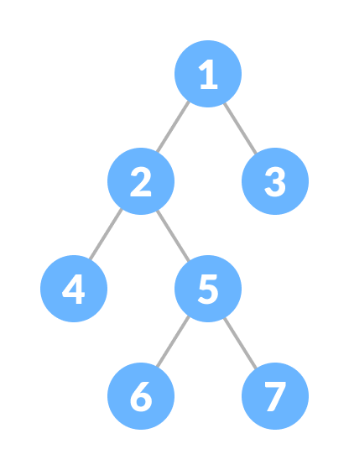**Balanced Binary tree**

### 1. Full Binary Tree

A full Binary tree is a special type of binary tree in which every parent node/internal node has either two or no children.

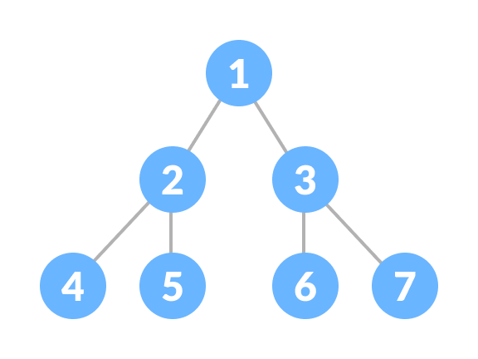

### 2. Perfect Binary Tree

A perfect binary tree is a type of binary tree in which every internal node has exactly two child nodes and all the leaf nodes are at the same level.

### 3. Complete Binary Tree

A complete binary tree is just like a full binary tree, but with two major differences

1. Every level must be completely filled
2. All the leaf elements must lean towards the left.
3. The last leaf element might not have a right sibling i.e. a complete binary tree doesn't have to be a full binary tree.

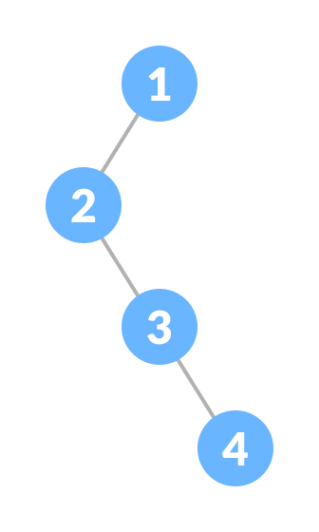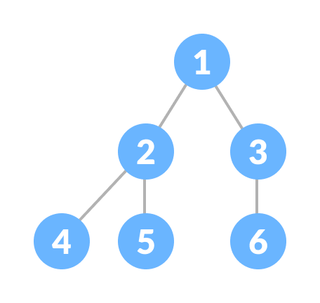

### 4. Degenerate or Pathological Tree

A degenerate or pathological tree is the tree having a single child either left or right.

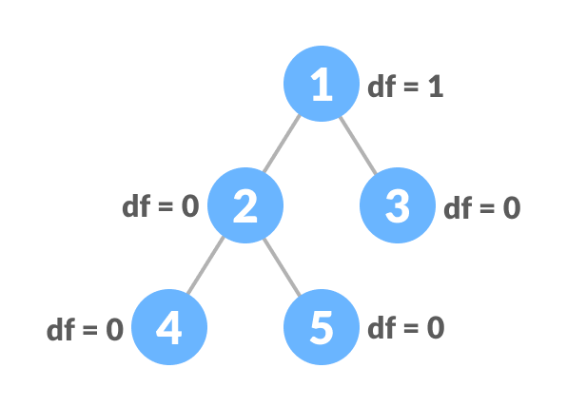

### **5. Balanced Binary Tree**

It is a type of binary tree in which the difference between the height of the left and the right subtree for each node is either 0 or 1.

